**Microsoft Schannel:**

The Windows operating system includes a security package called Microsoft Schannel (Secure Channel) that supports secure communication protocols including SSL (Secure Sockets Layer) and TLS (Transport Layer Security). The negotiation and construction of secure connections between programs running on Windows-based PCs is managed by Schannel.

Secure Internet communication is made possible by the cryptographic protocols and methods offered by Schannel. Moreover, it supports certificate-based authentication and network traffic encryption, shielding sensitive data from eavesdropping and manipulation.

Internet Explorer, Microsoft Edge, Microsoft Office, and Windows Server are just a few of the Microsoft products that use Schannel to connect securely to web servers, mail servers, and other network services. Developers can utilize Schannel's APIs to include secure communication in their own apps.

Several cryptographic techniques, including RSA, Diffie-Hellman, and elliptic curve encryption, are supported by the Schannel libraries (ECC). Digital signatures and certificate-based authentication are also supported by them.

Microsoft updates the Schannel libraries frequently to fix security flaws, enhance performance, and increase interoperability with other programs and systems. To maintain the security and dependability of Windows-based systems, it is crucial to keep these libraries up to date. Some features of these libraries are:

* Implementation of the SSL/TLS protocols: The SSL (Secure Sockets Layer) and TLS (Transport Layer Security) protocols are implemented by the Microsoft Schannel libraries. Applications like web browsers, email clients, and instant messaging software all make use of these protocols to offer secure network connections.
* Security flaws: The POODLE and BEAST attacks, among others, have made Schannel libraries susceptible to a number of security flaws in the past. To fix these flaws and increase the security of the Schannel libraries, Microsoft publishes security updates and patches.
* Schannel libraries support a number of cryptographic protocols, including RSA, Diffie-Hellman, and elliptic curve cryptography (ECC). These methods enable secure key exchange and data encryption while communicating.
* Certificate-based authentication is a secure method of identifying a user or a system, and Schannel libraries support it. Digital files known as certificates are created by reputable organizations and contain data on the identity of the user or machine. Throughout the authentication procedure, Schannel libraries check the validity of the certificates that the user or system presents.
* Schannel libraries include support for digital signatures, which are used to confirm the integrity and authenticity of digital data. A public key can be used to verify digital signatures, which are generated using a cryptographic method, and a private key.

In conclusion, Schannel is an important part of Windows' security infrastructure since it offers secure communication features necessary for safeguarding sensitive information and preserving the integrity of network traffic.

**Vulnerabilities:**

* **Beast attack:**

The acronym BEAST stands for Browser Exploit Against SSL/TLS. It is a network vulnerability attack against TLS 1.0 and earlier SSL protocols. The attack was initially carried out in 2011 by security researchers Thai Duong and Juliano Rizzo, but Phillip Rogaway first identified the potential vulnerability in 2002. Man-in-the-middle attack approaches might allow attackers to listen in on the communication between a web server and a web browser. If they do and there is no encryption, they can see all the data sent back and forth between the web server and web browser, including passwords, credit card numbers, and other personal information even encryption, though, may have flaws and be broken.

This is precisely what happened during the BEAST attack. The researchers discovered that TLS 1.0 (and earlier) encryption can be swiftly cracked, allowing the attacker to overhear the communication. A block cipher could be broken by the attacker by testing several combinations to determine if they provide the same outcome with the same initialization vector (which they know). Nevertheless, they can only do it for an entire block at once, and a block, for example, might include 16 bytes. As a result, the attacker would need to try 25616 combinations (3.4028237e+38) for each block in order to check the block.

The BEAST attack makes this considerably easier by requiring the attacker to guess a single byte at a time. This is possible if the attacker only requires one piece of sensitive information, such as a password, and can guess the majority of the data (such as HTML code, for example). The attacker can then carefully test the encryption by choosing the proper data length such that they only have one byte of information in a block that they are unfamiliar with. The block can then be tested using only 256 different permutations of this byte. They then carry out the same procedure for the following byte, eventually obtaining the complete password.

It is relatively simple to determine whether your web server is susceptible to BEAST. It is susceptible to BEAST if it supports TLS 1.0 or any SSL version. The RC4 cipher was initially advised as a defense against BEAST attacks (because it is a stream cipher, not a block cipher). RC4 was eventually discovered to be dangerous, though. The Payment Card Industry Data Security Standard (PCI DSS) currently forbids the usage of this encryption. As a result, you shouldn't ever defend yourself against BEAST using this technique.

Turning off TLS 1.0 and earlier protocols is the only straightforward cure for BEAST, just like it is for other network problems. For the most popular web server software, follow these steps. Moreover, we advise turning off TLS 1.1 and just enabling TLS 1.2. (all major browsers such as Google Chrome, Firefox, and Safari support TLS 1.2).

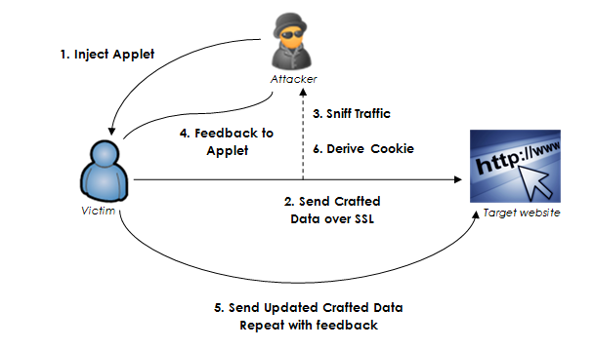

* WinShock:

A security flaw called WinShock, often referred to as MS14-066, affects the Secure Channel (Schannel) security package in Microsoft Windows. The flaw was identified in 2014, and Microsoft gave it a critical rating. By delivering a carefully designed packet to the Schannel security package, the WinShock vulnerability enables an attacker to remotely execute code on a server running Microsoft IIS (Internet Information Services). As a result, the attacker may be able to take total control of the server, steal sensitive information, or introduce malware. All supported versions of Microsoft Windows, including Windows Server 2003, Windows Server 2008, Windows Server 2012, as well as Windows 7, 8, and 8.1, are impacted by the vulnerability. It results from a problem with the way Schannel manages packets that have been carefully constructed during the TLS/SSL handshake. In November 2014, Microsoft issued a security update to fix the WinShock flaw. Applying this update as soon as you can will help stop attackers from taking advantage of the vulnerability. To further lower the danger of exploitation, it is advised to adhere to best practices for secure application development, such as input validation and appropriate error handling.

**References:**

1. <https://niiconsulting.com/checkmate/2013/12/ssltls-attacks-part-1-beast-attack/>
2. <https://www.rapid7.com/resources/winshock-what-is-it-how-to-remediate/>
3. <https://www.techtarget.com/searchsecurity/tip/SSL-TLS-security-Addressing-WinShock-the-Schannel-vulnerability>
4. <https://www.acunetix.com/blog/web-security-zone/what-is-beast-attack/>
5. <https://learn.microsoft.com/en-us/windows-server/security/tls/tls-ssl-schannel-ssp-overview>